**Model Predictive Control Based Jumping of Robotic Leg on a Particular height using Reinforcement Learning**

**Project Requirement document with diagrams and Statement of work**

**1. Introduction**

This document outlines the requirements and framework for developing a robotic leg that can jump to a specific height using a Model Predictive Control (MPC) strategy enhanced with Reinforcement Learning (RL).

**2. Project Overview**

The project aims to design and implement a robotic leg system that utilizes MPC to determine the optimal trajectory for jumping, incorporating RL for continuous learning and improvement.

**3. Stakeholders**

* Project Sponsor: Provides funding and resources.
* Project Manager: Oversees project execution.
* Development Team: Responsible for algorithm and hardware development.
* Testing Team: Validates system performance and safety.
* End Users: Operate the robotic leg in practical scenarios.
* Advisors: Offer expertise in robotics and control systems.

**4. Business Goals**

Target users include researchers, educators, and industries focusing on robotics.

Create a robust jumping mechanism for varied applications (e.g., search and rescue, entertainment).

**5. Features**

Real-time monitoring of jumping performance.

User-friendly interface for system control and parameter tuning.

Adaptive learning through reinforcement learning.

Safe operation with obstacle detection.

**6. Challenges**

Maintaining stability during jumps.

Real-time data processing and control.

Effective learning in dynamic environments.

**7. Project Need**

The project addresses the growing need for agile robots capable of navigating complex environments, enhancing operational efficiency in various sectors.

**8. Alternatives**

Traditional control systems (PID) vs. MPC.

Different ML techniques: supervised vs. reinforcement learning.

**9. Competitive Analysis**

Unique focus on combining MPC with RL for adaptive control.

User interface designed for ease of use, differentiating from competitors with more complex systems.

**10. Risk Management**

Identify risks such as system failures and control inaccuracies.

Implement regular testing and feedback loops to mitigate risks.

**11. Scope Management**

Define project boundaries clearly to manage expectations.

Establish a change management process for scope requests.

**12. Solution Design**

Investigate MPC algorithm performance.

Explore sensor integration for real-time feedback.

**13. Technology Analysis**

MPC: Offers predictive control but may be computationally intensive.

Reinforcement Learning: Requires significant training time but enhances adaptability.

**Comparison of Technologies:**

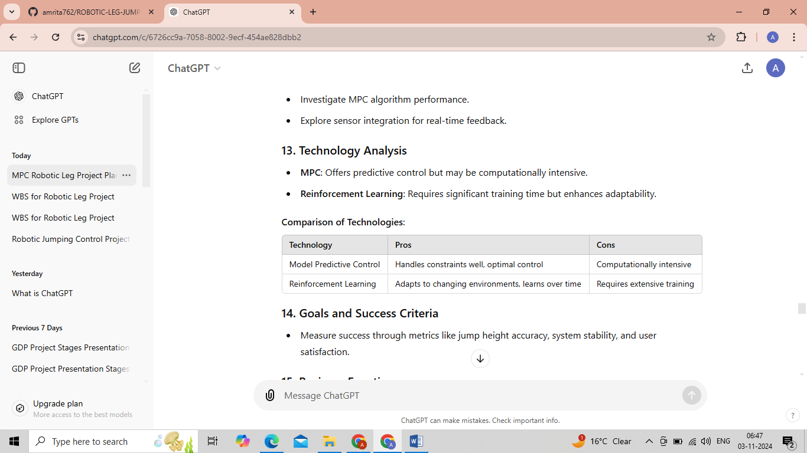

**14. Goals and Success Criteria**

Measure success through metrics like jump height accuracy, system stability, and user satisfaction.

**15. Business Functions**

The project's vital functions include:

Performance optimization.

User interaction and control.

Real-time data analysis.

**16. Release and Deployment**

Phased deployment strategy:

Simulation testing.

Controlled environment trials.

Real-world implementation.

**17. Objectives and Outcomes**

Develop a functional prototype capable of controlled jumping.

Validate MPC and RL integration through testing.

**18. Learning Statement**

This project will enhance understanding of control systems and ML applications in robotics.

Skills in algorithm development and system integration will be improved, contributing to professional growth.

**19. Diagrams**

**Block Diagram/System Diagram**

**+-------------------+ +------------------------+**

**| Environment |<----->| Sensor Feedback |**

**+-------------------+ +------------------------+**

**|**

**|**

**+-------------------+**

**| Robotic Leg |**

**| |**

**+-------------------+**

**|**

**|**

**+-------------------+---------------------+**

**| |**

**+-----------------+ +------------------+**

**| MPC | | RL Agent |**

**+-----------------+ +------------------+**

**| |**

**+-------------------+---------------------+**

**|**

**+-------------------+**

**| Data Processing |**

**| Unit |**

**+-------------------+**

**|**

**+-------------------+**

**| User Interface |**

**+-------------------+**

**Use Case Diagram –**

**+-------------+**

**| User |**

**+------+------+**

**|**

**+-----------+----------+**

**| |**

**+----v----+ +-----+-----+**

**| Start | | Monitor |**

**| Jump | | Performance |**

**+---------+ +-----+-----+**

**|**

**+-------+-------+**

**| Adjust |**

**| Parameters |**

**+-------+-------+**

**|**

**+---------+---------+**

**| Collect |**

**| Data |**

**+---------+---------+**

**|**

**+-------+-------+**

**| Train RL |**

**| Agent |**

**+---------------+**

**Statement of Work (SoW**)

**1. Introduction**

This Statement of Work outlines the objectives, scope, and deliverables for the development of a Model Predictive Control-based jumping mechanism for a robotic leg using reinforcement learning.

**2. Project Objectives**

Develop an MPC algorithm for optimal jumping trajectory.

Integrate an RL model for continuous learning.

Build a user interface for monitoring and control.

**3. Deliverables**

Functional prototype of the robotic leg.

Documentation of algorithms and system architecture.

User manual for operation and troubleshooting.